DEPLOY WEB APP AMAZON LINUX
- What is the protocol we have to follow whenever we want to connect any remote server?
- So it is SSH (Shell Secure Host). It will run on port number 22 only.
- Whenever you are launching EC2 instance, you have to check whether it is enabled or not.
- If enabled, ok. If it is not enabled, you have to enable it.
- If it is not enabled then it will not connect within the console & as well as putty also.
- If it is enabled then it is safe from hacking also.
- Now we want to create EC2 instance as amazon linux.
STEP 1: Sign in to AWS account. Click on the option EC2🡪instances🡪launch instance.
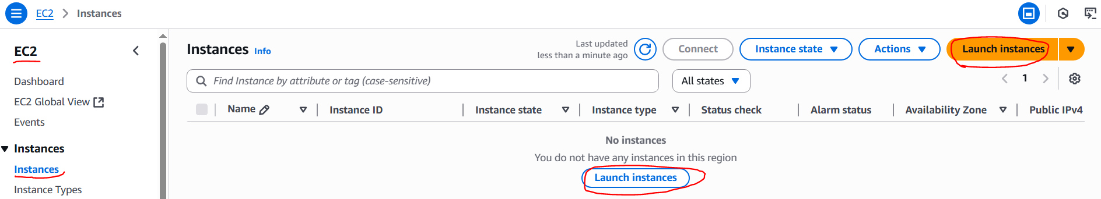
STEP 2: Now create an EC2 instance as shown below.
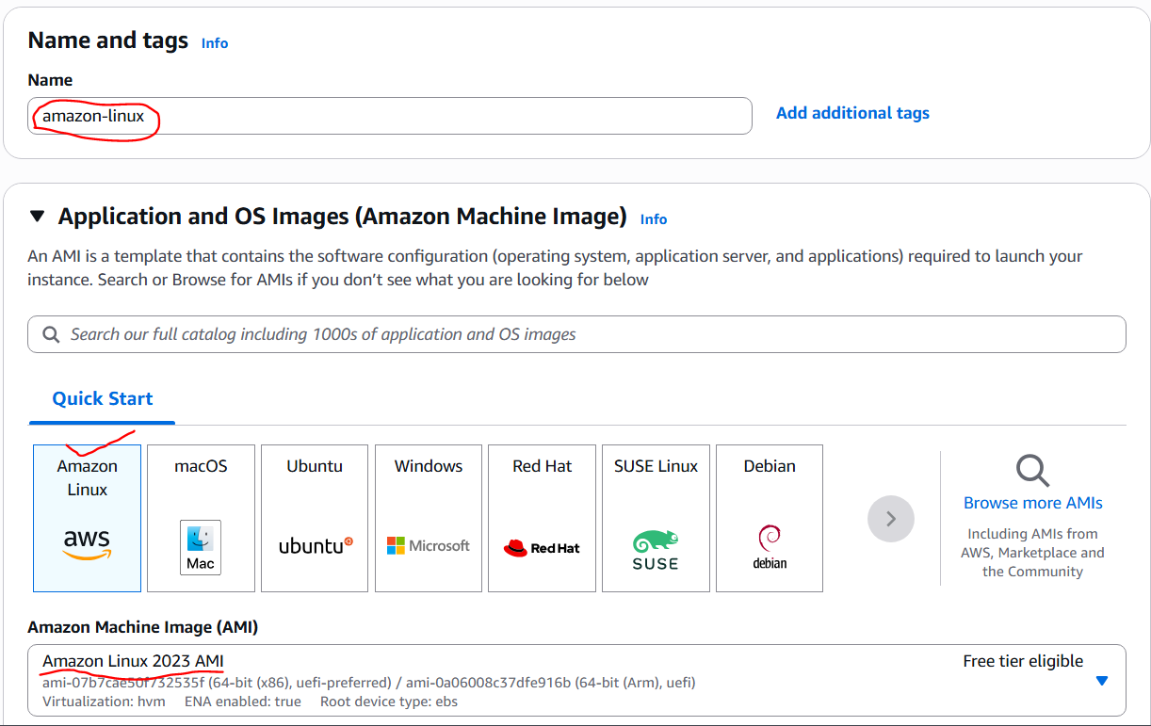
- Now give instance type small only why because we need to create one instance only. Also create a keypair by using the option create keypair.
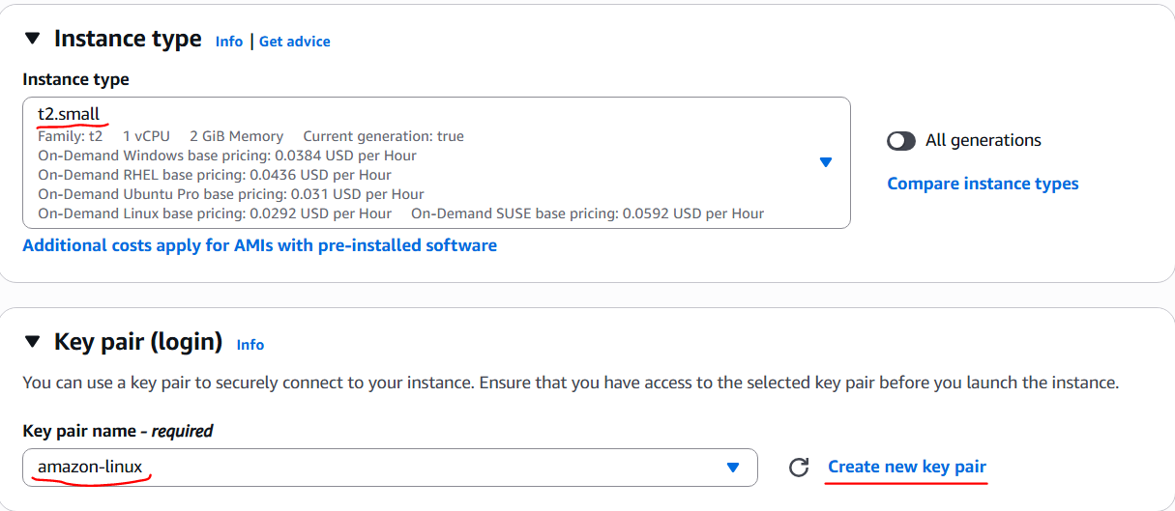
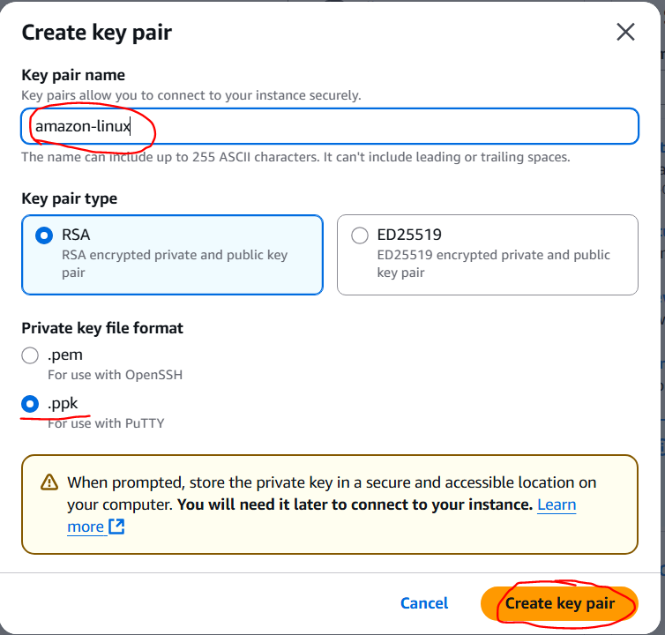
- Now create security group by clicking the option create security group. After that ensure SSH check box is selected.
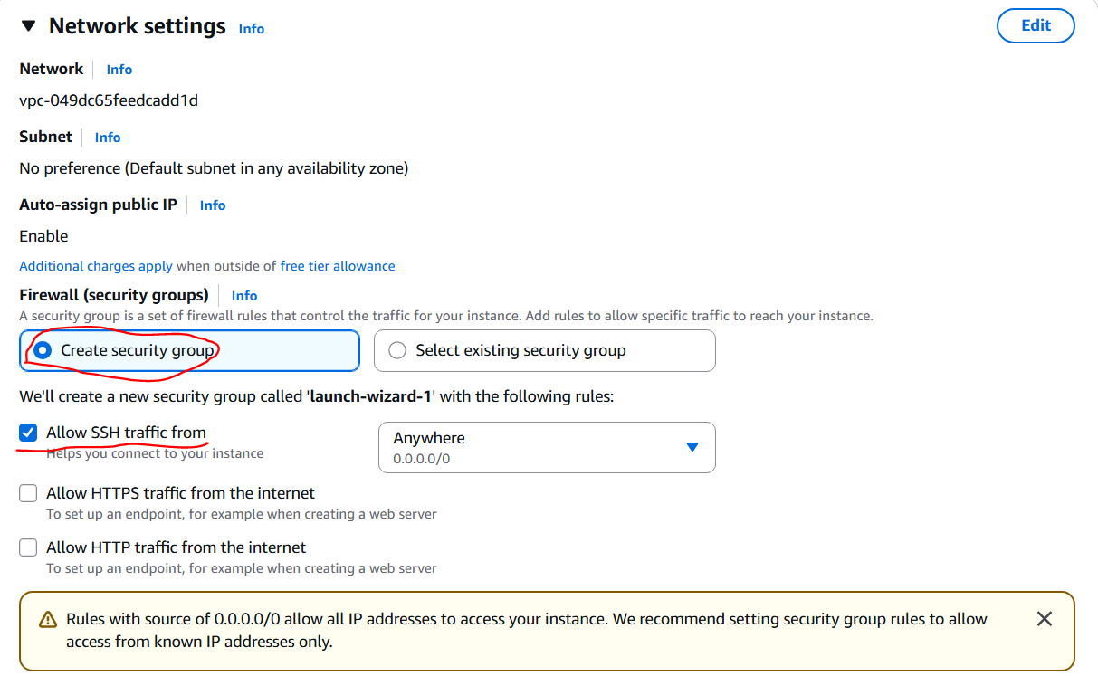
- Configuration storage we can give 15. Click launch instance option.
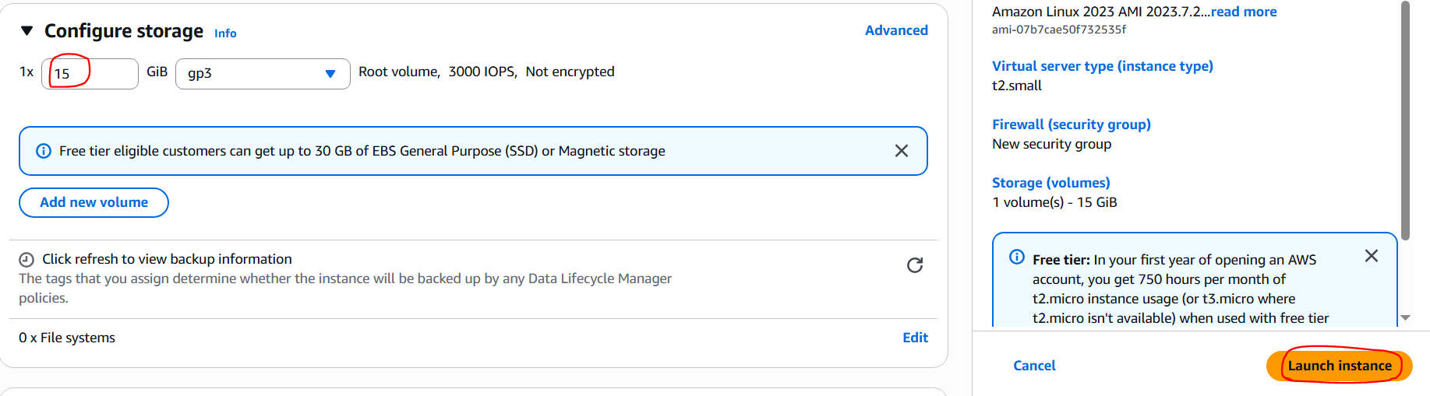
- My instance is finally like this.
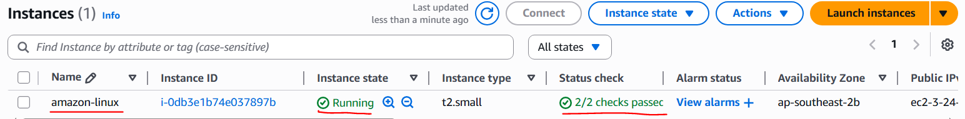
STEP 3: Now connect the EC2 instance by clicking the option connect. The page will be as shown below.
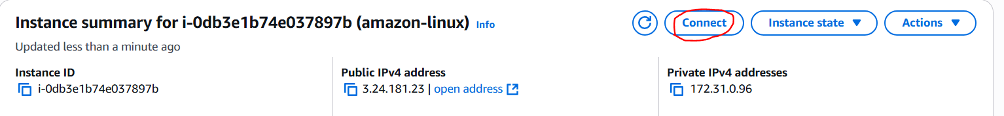
- There are 2 ways to connect. 1. Within the console that means if u don’t have putty or mobaxterm we can connect like this.
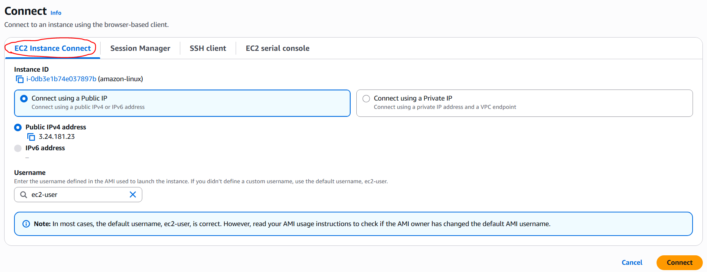
- 2. On premisis that means using putty or mobaxterm using SSH Client.
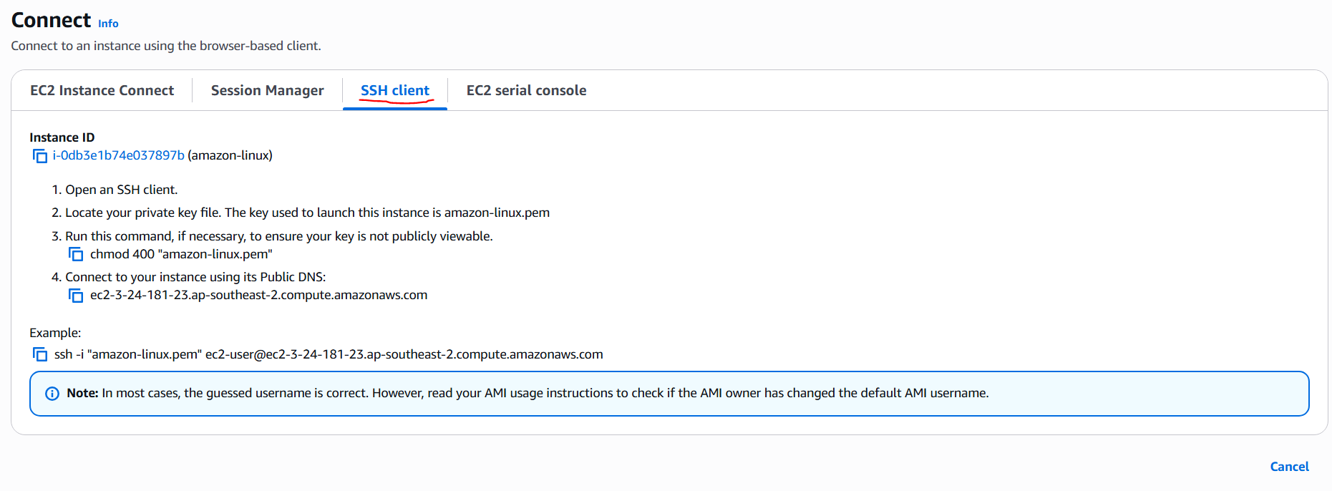
STEP 4: Now open putty. Copy & paste the public IP Address of EC2 instance or copy the public DNS.
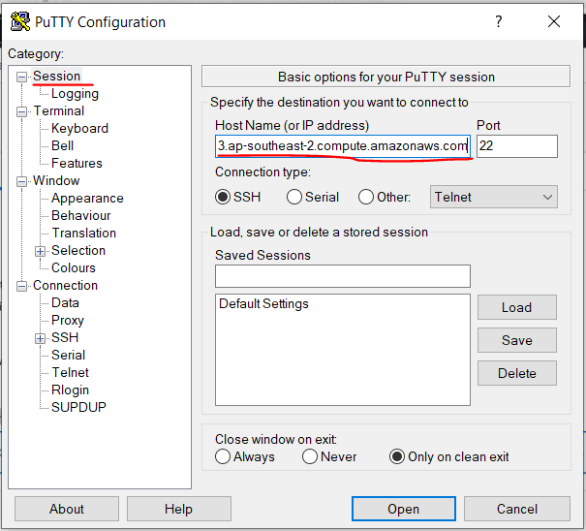
- Appearance🡪font🡪change.
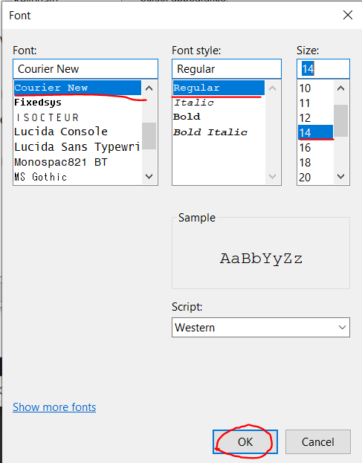
- Connection🡪keepalive (60 seconds)
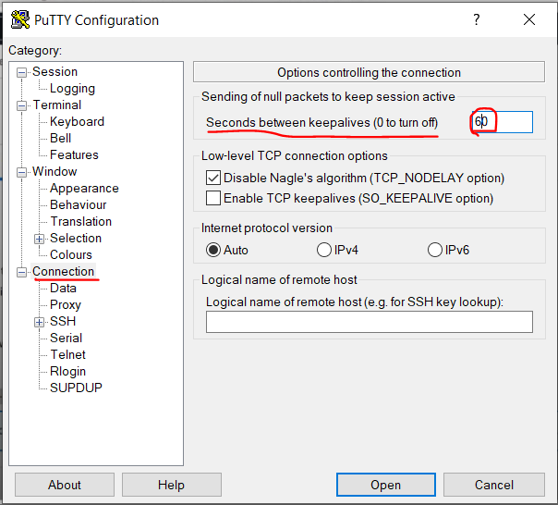
- SSH🡪Auth🡪credentials🡪private key file (keypair .ppk file). Now click open option.
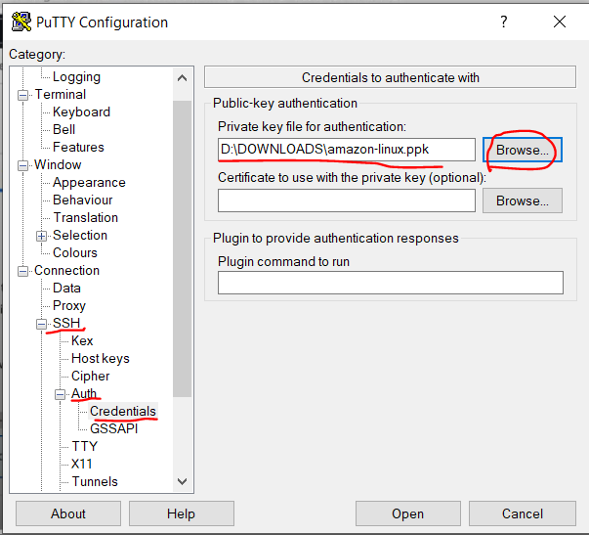
- Console screen asking u permission & putty screen is as shown below.
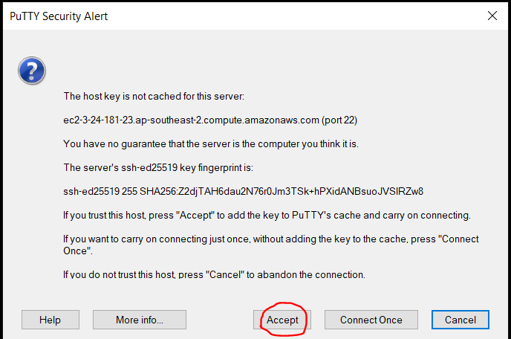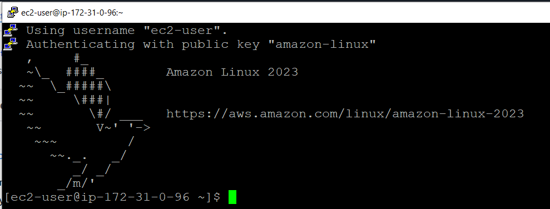
STEP 5: Now switch to root user using the command sudo su.
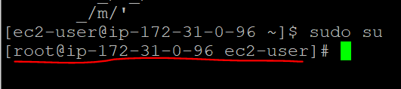
STEP 6: Here the package manager of amazon linux is yum( Yellowdog Update Modifier). It is also used for redhat, cent OS, suse linux. Apt is for Ubuntu.
- Now update the system by using the command yum update –y.
STEP 7: Now I want to deploy a bank web application for that I have created one directory. I have checked whether the directory is created or not by using the command ls.
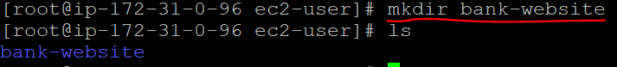
- Now go into that directory, start creating necessary files like first create index.html file.
- Here for creating the file, don’t use touch command because touch command only create the file, vi command creates the file & opens the file.
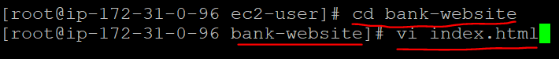
- Now give the command vi index.html then it opens a console for code. Copy & paste the code in that console & click esc+:wq for coming into the main console.
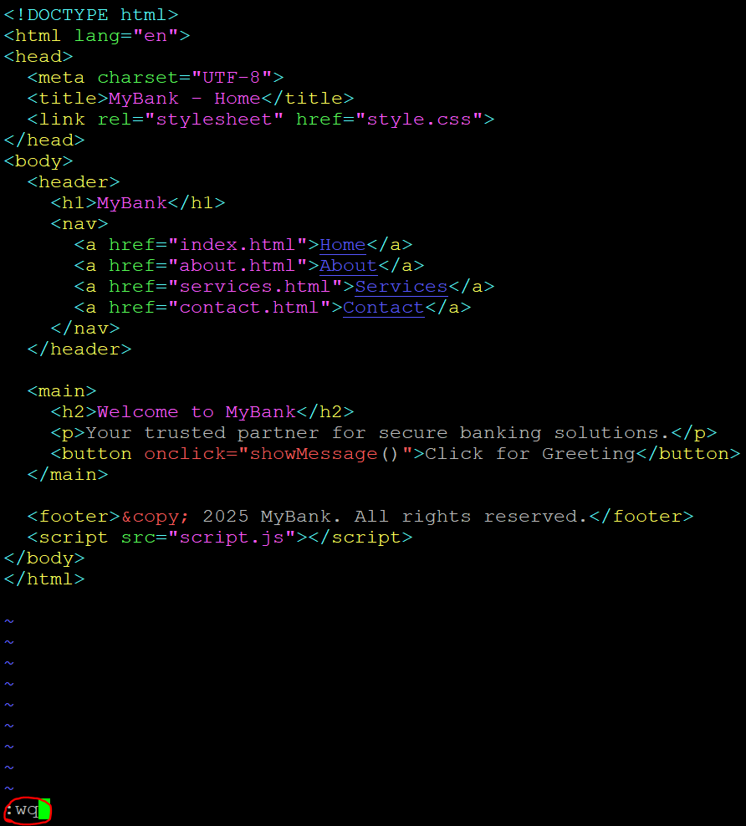
- Now for checking the code in index.html, type the command cat index.html
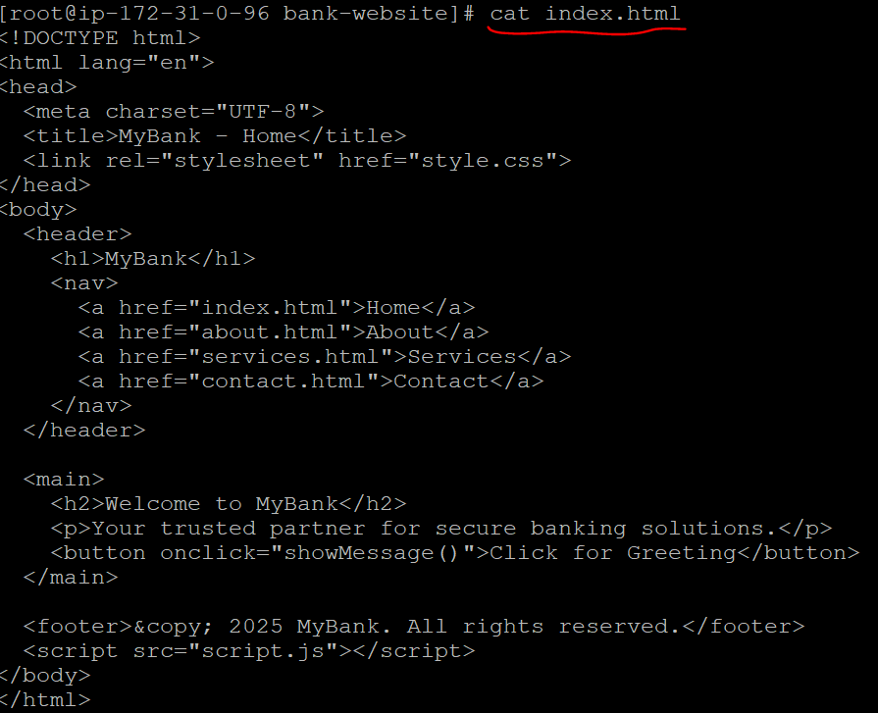
- Now create another file, type the command vi about.html
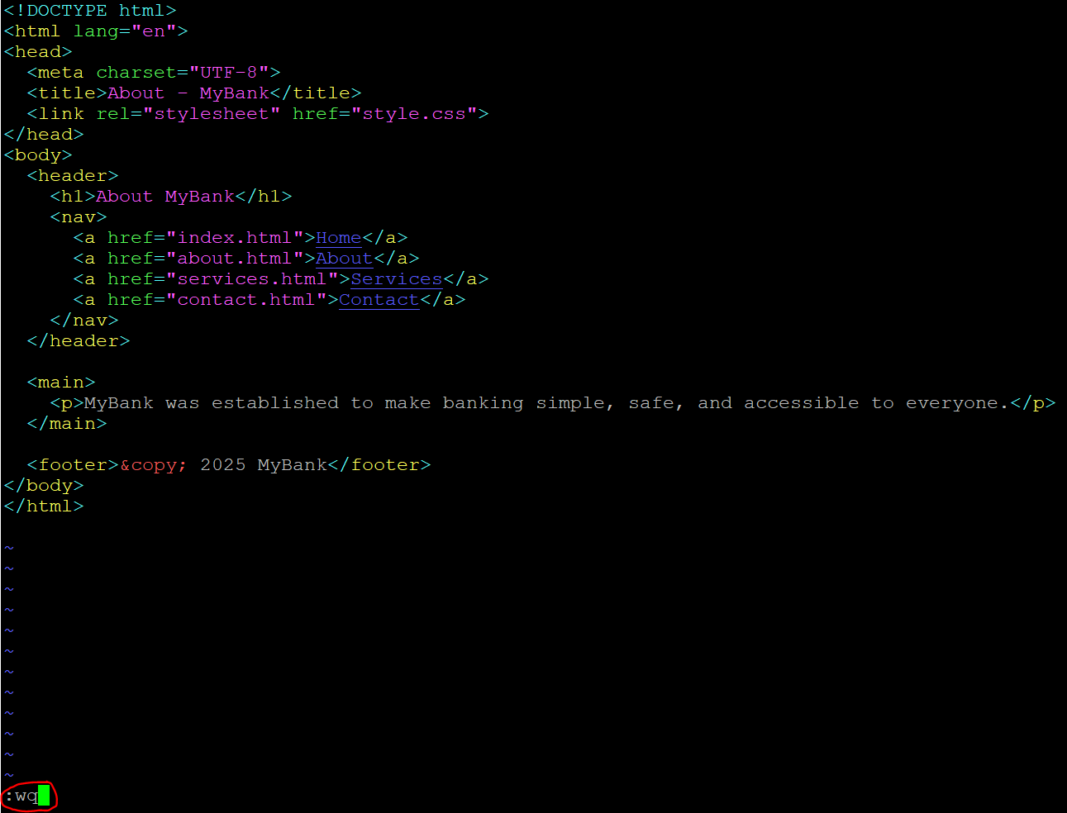
- Now create another file, vi services.html
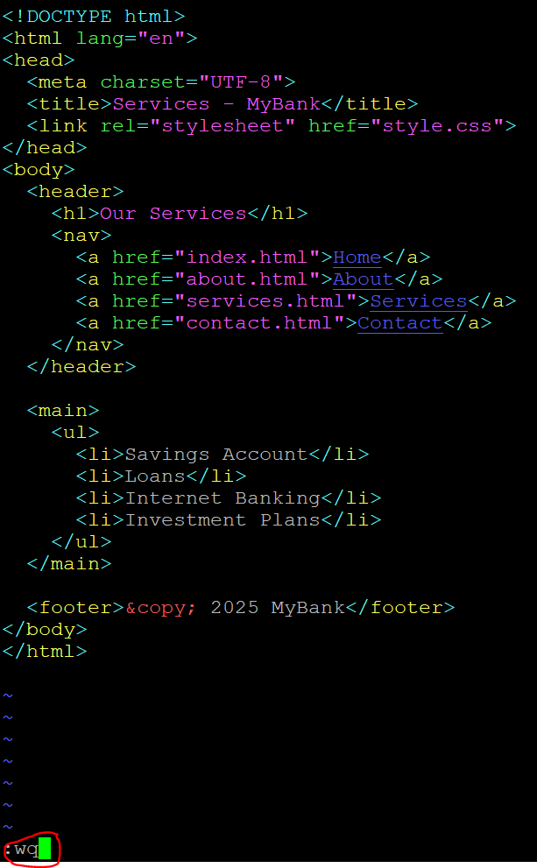
- Create another file, vi contact.html

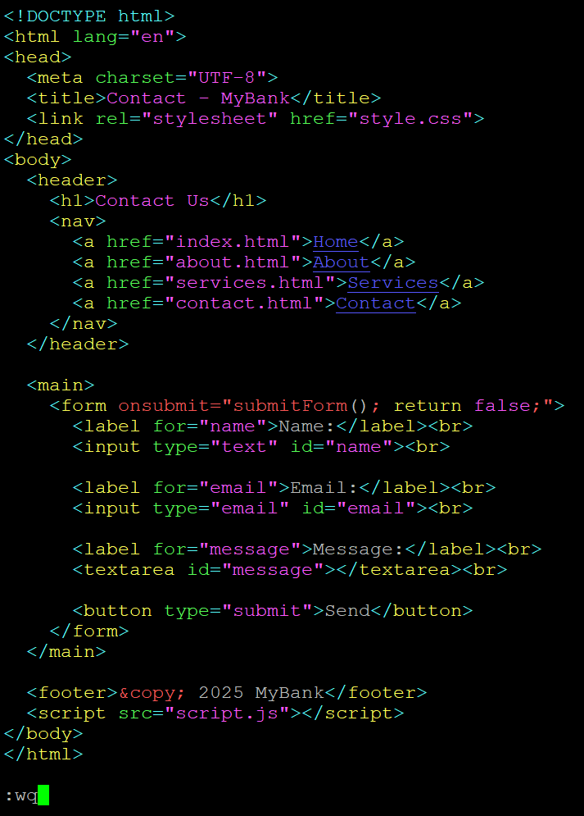
- Create file, vi style.css
- Create file, vi script.js
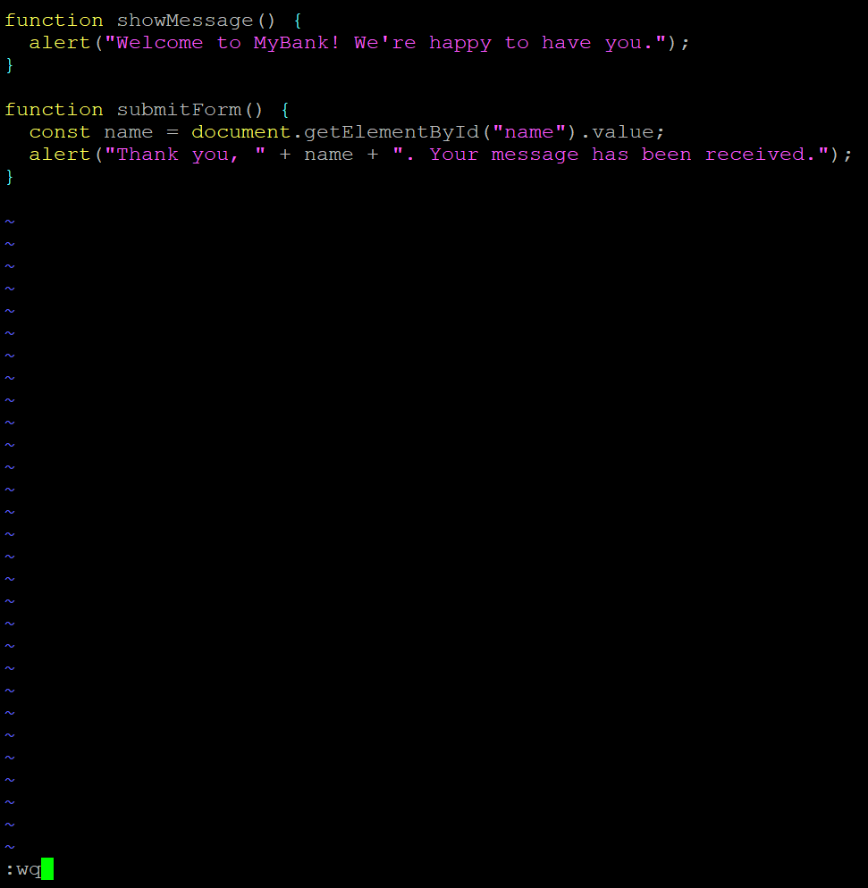
- Now type the command ls –ltr, this will tell you what are the permissions the files you have.

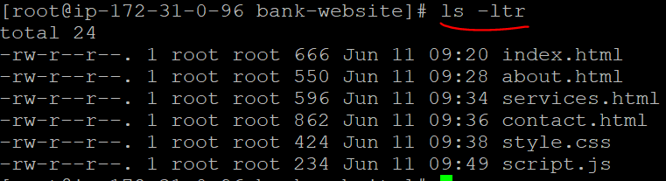
- Now you have to download a webserver. Apache is for Ubuntu, Httpd is for amazon linux. But port number is same i.e 80 only & root location of these web servers is /var/www/html.
- Now install Httpd by using the command yum install httpd –y.
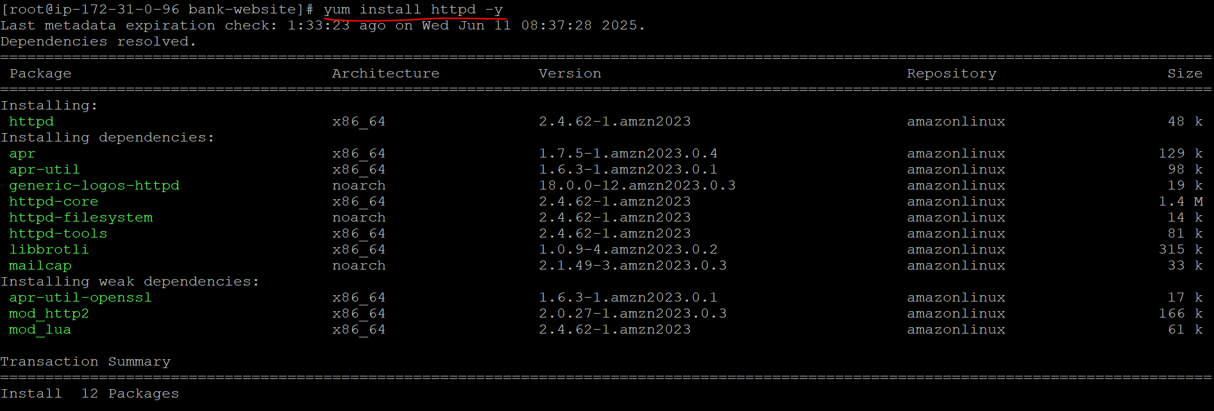
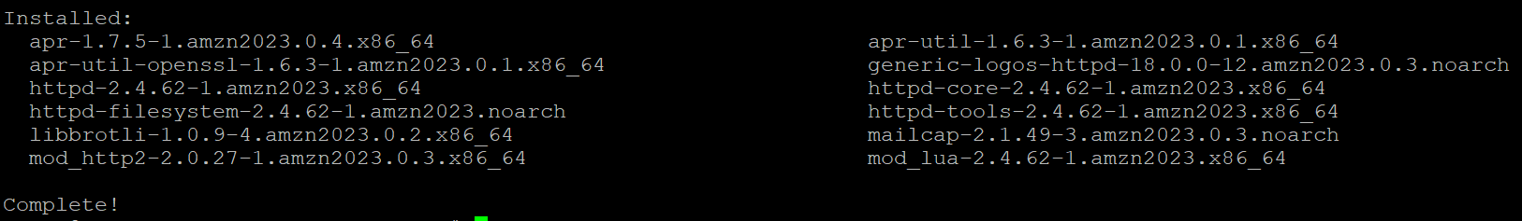
- Now check the status of httpd by using the command service httpd status.
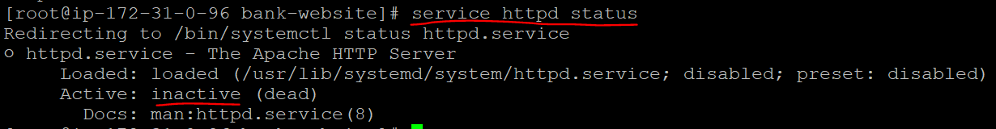
- Now start the httpd by using the command service httpd start.
- Now again check the status.
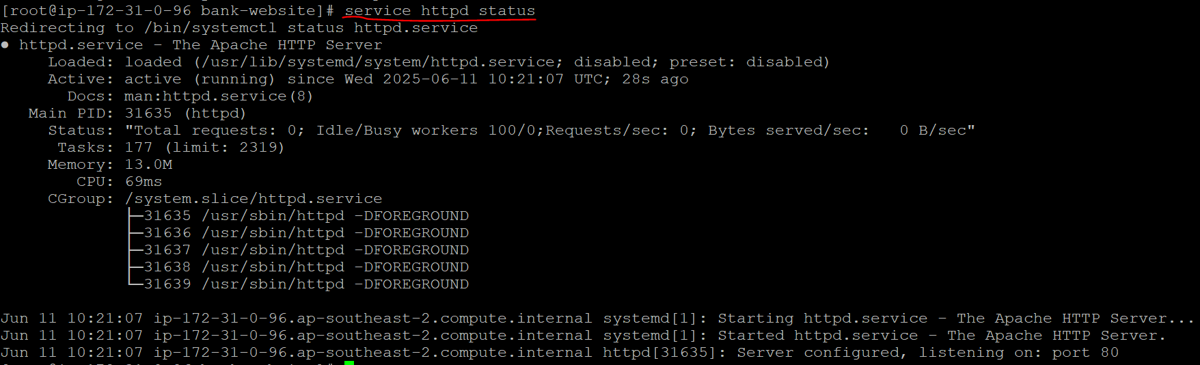
- Now give the command cp –r . /var/www/html. Here cp means copy, -r means repo, . means where your source code files are available. Give ls command to check this.
- Now go to the destination location & check whether the files are there or not.
- Now copy the public IP Address of the EC2 instance & paste it in google then see whether my application is accessed or not.
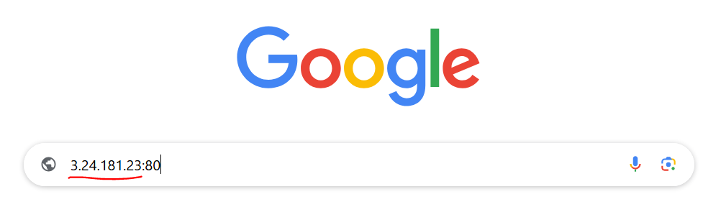
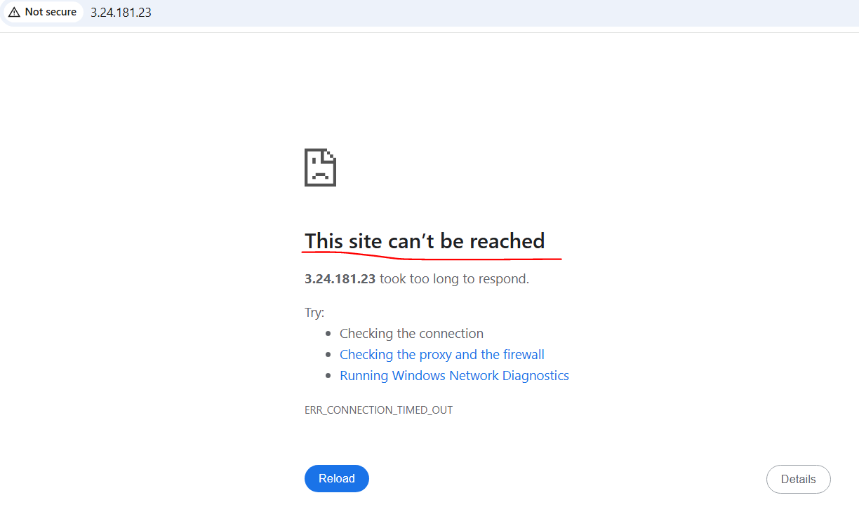
- This is why because we didn’t give this port number (80) in network settings in EC2 instance.
- Now go to EC2 instance🡪network settings🡪inbound rules🡪Edit inbound rules. Inbound allows traffic, outbound doesn’t allows traffic.
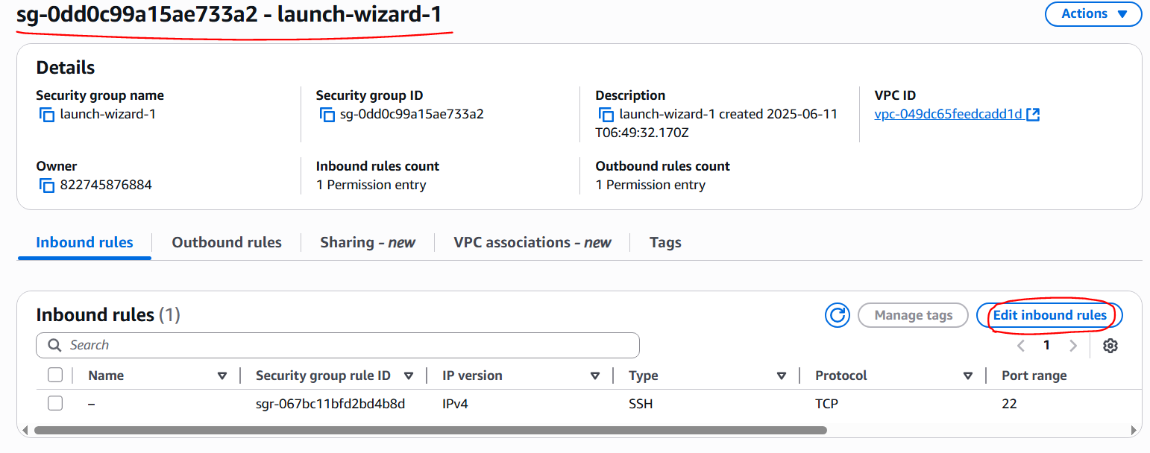
- Now click add rule option.
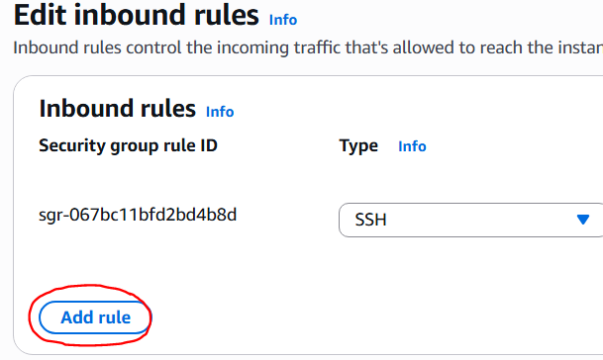
- Now add rule HTTP. Click save rules.
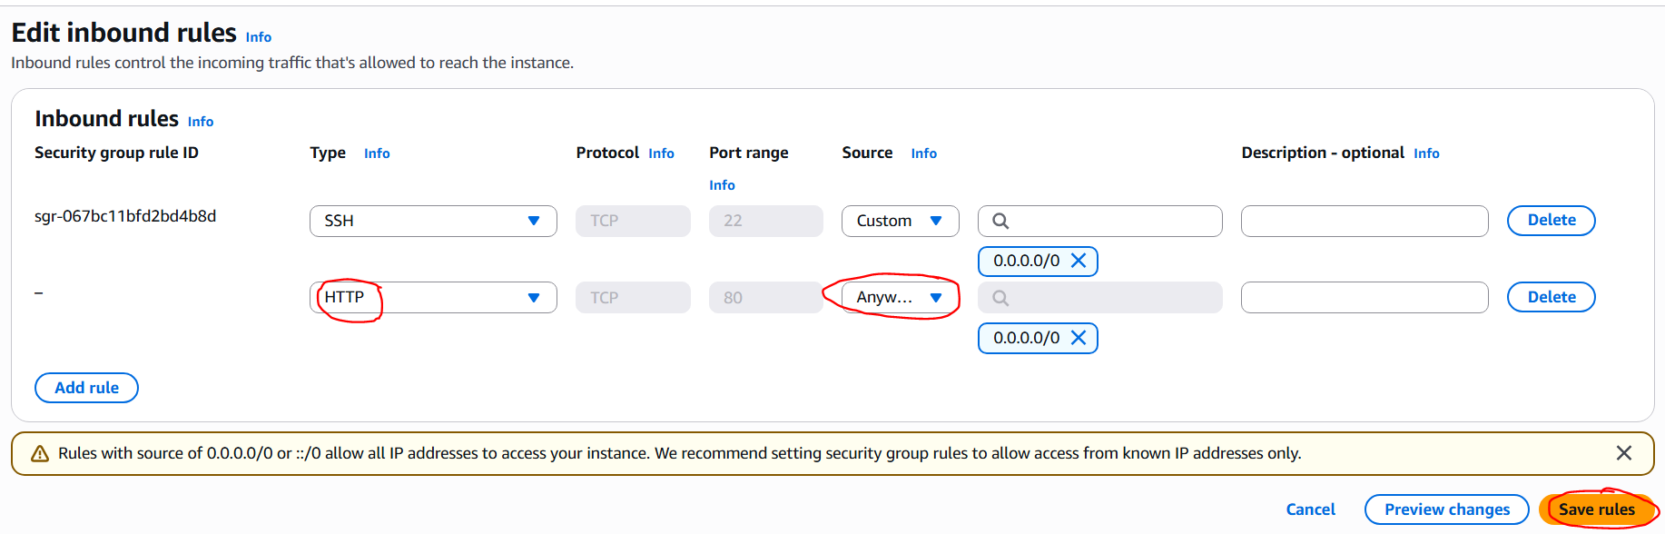
- Now go to browser where you have pasted the public IP Address & refresh the page then the output is as shown.
Home page:
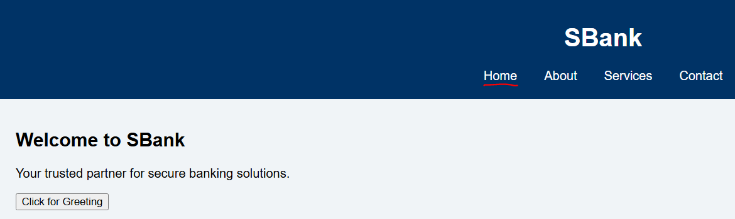
About page:
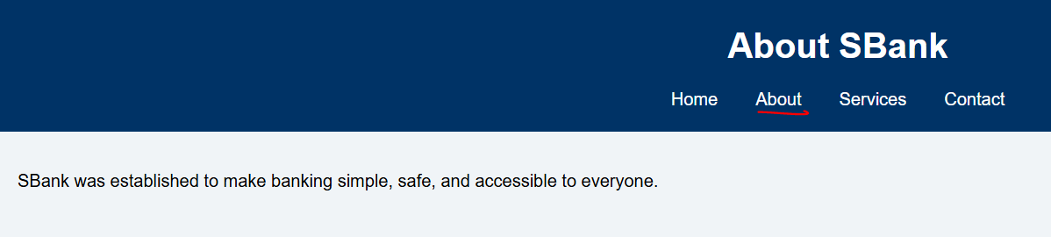
Services page:
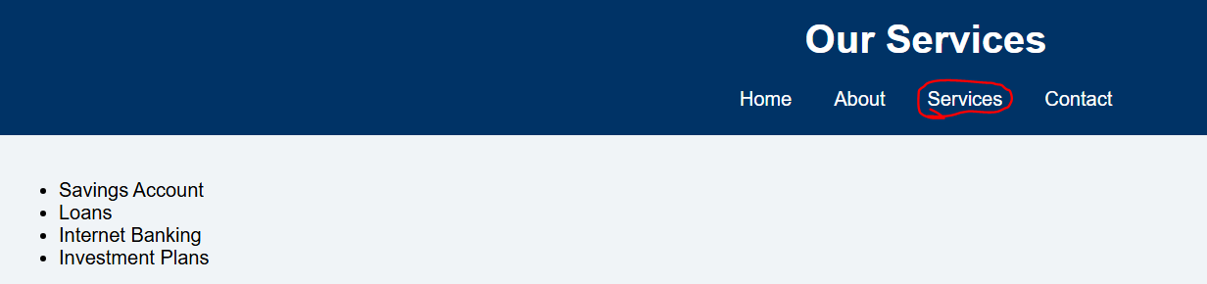
Contact page:

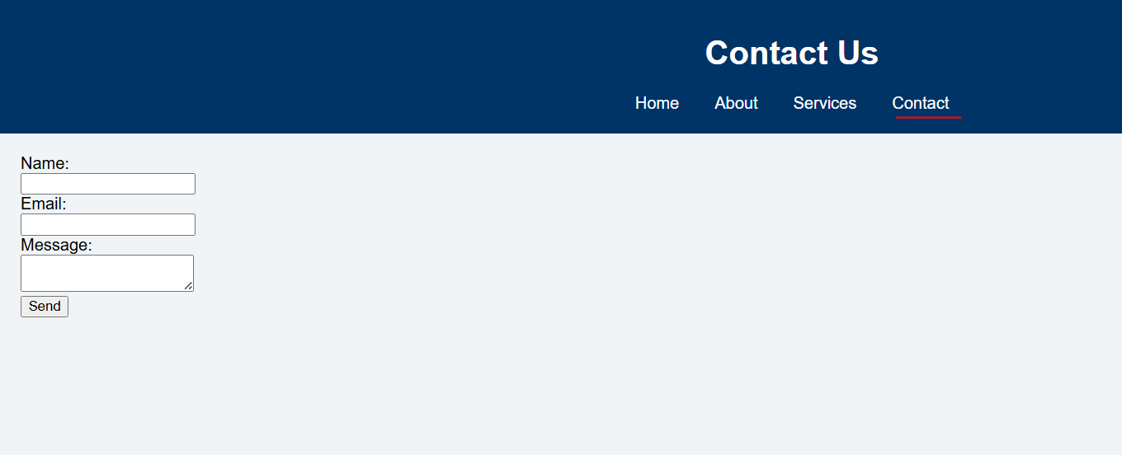
- Now go to github account🡪new repository.
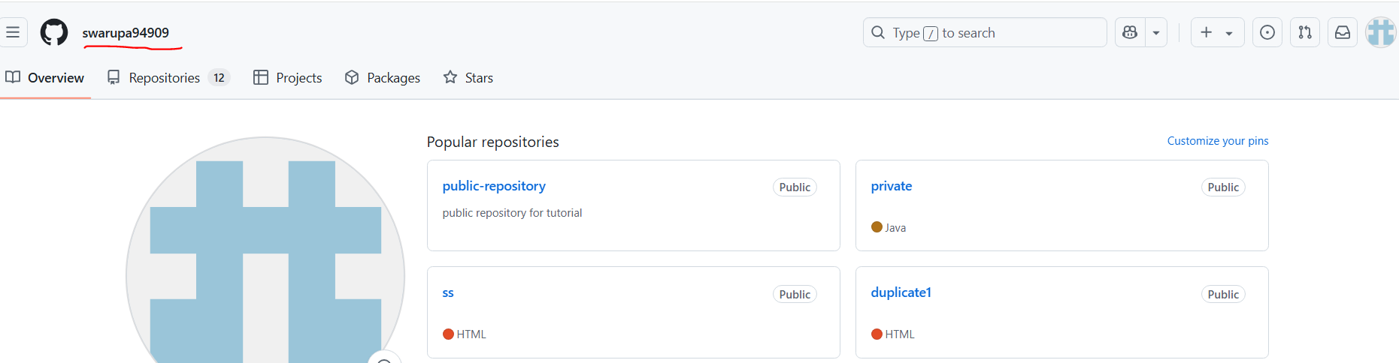
- This is the page while creating new repo. Click create repository.
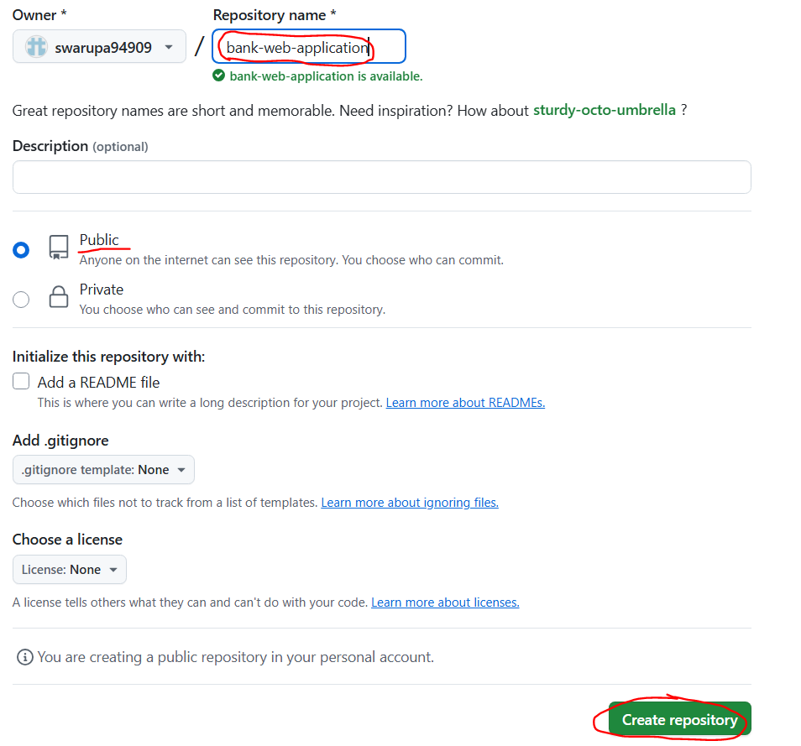
- Now initialize the git repo by using the command git init.
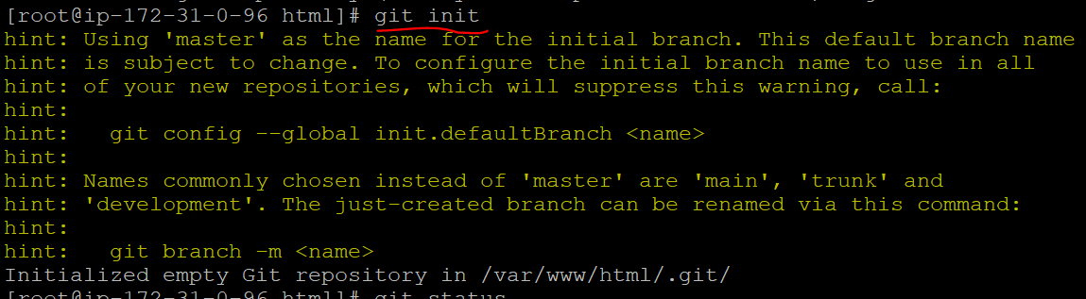

- Now check the status of git.
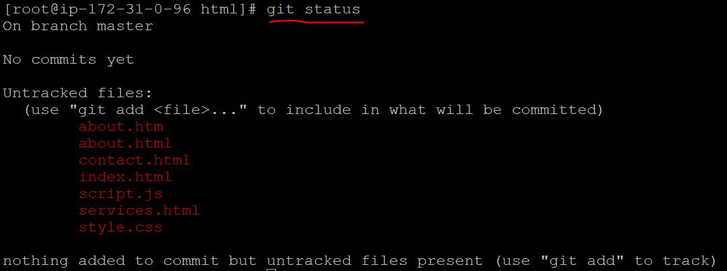
- Now add the files to the repo & check the status.
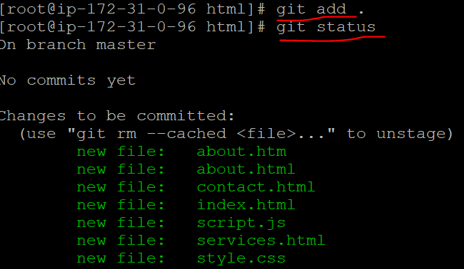
- Now commit the changes. Here 7 files means (1 directory & 6 files), 166 insertions means 166 lines are available in my application source code.
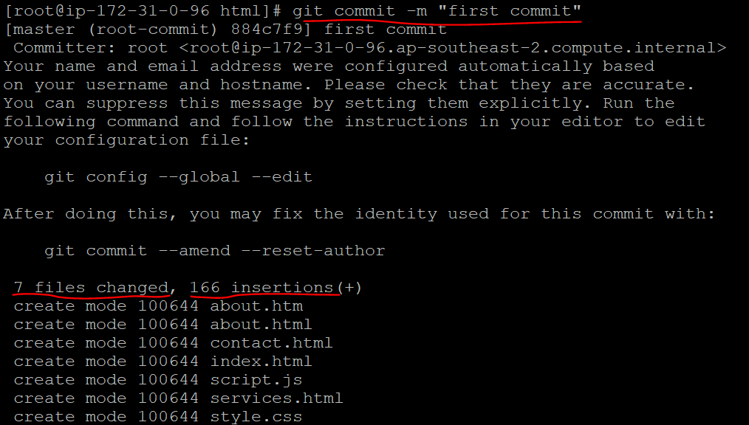
- Now give below commands for branch & adding remote origin.
- Now try to push the code then it asks about username, password. Give username of your github account but for password we have to generate tokens.
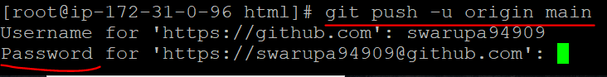
- For generating tokens, go to github account🡪settings🡪developer settings🡪personal access tokens🡪classic.
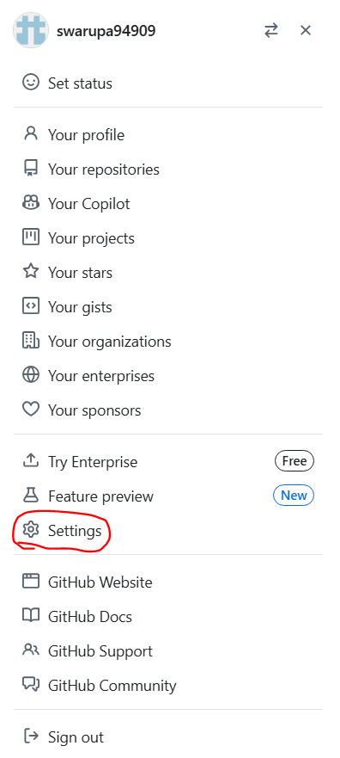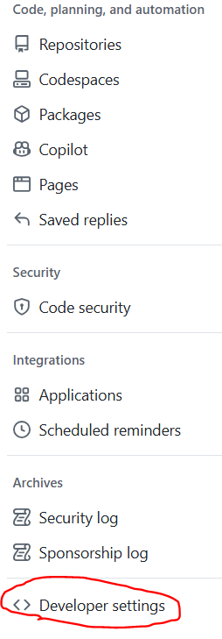
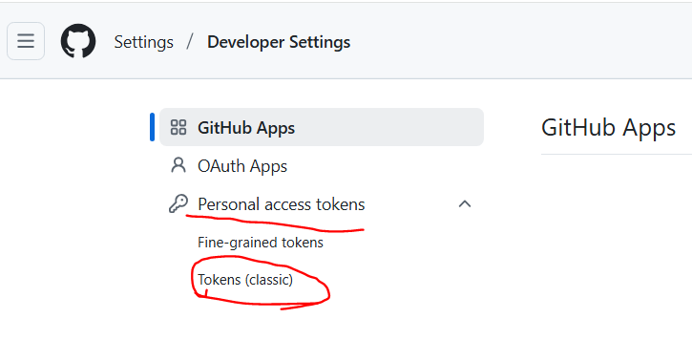
- Now click on generate new token🡪classic.
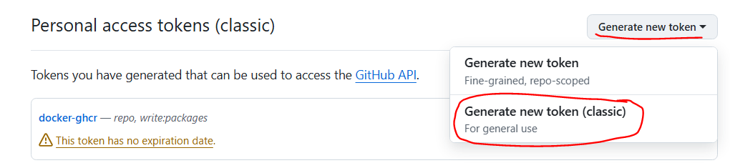
- Now my token asks these details. Fill it.
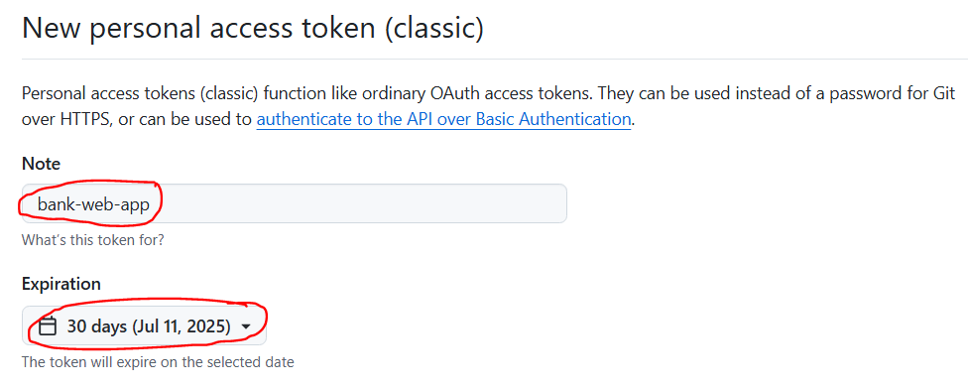
- Now click all the check boxes
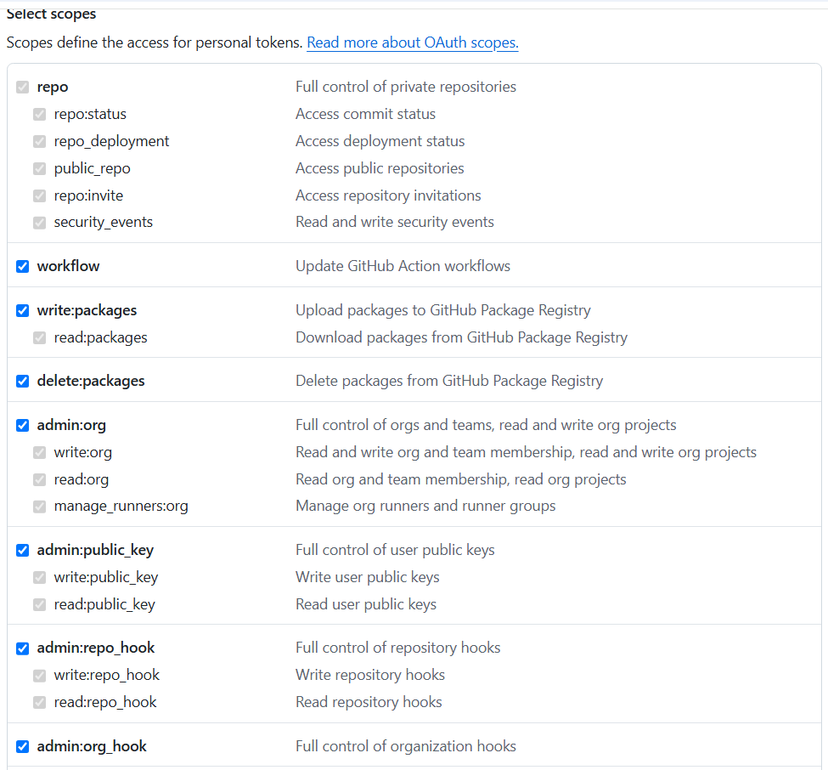
- Now click generate token option.
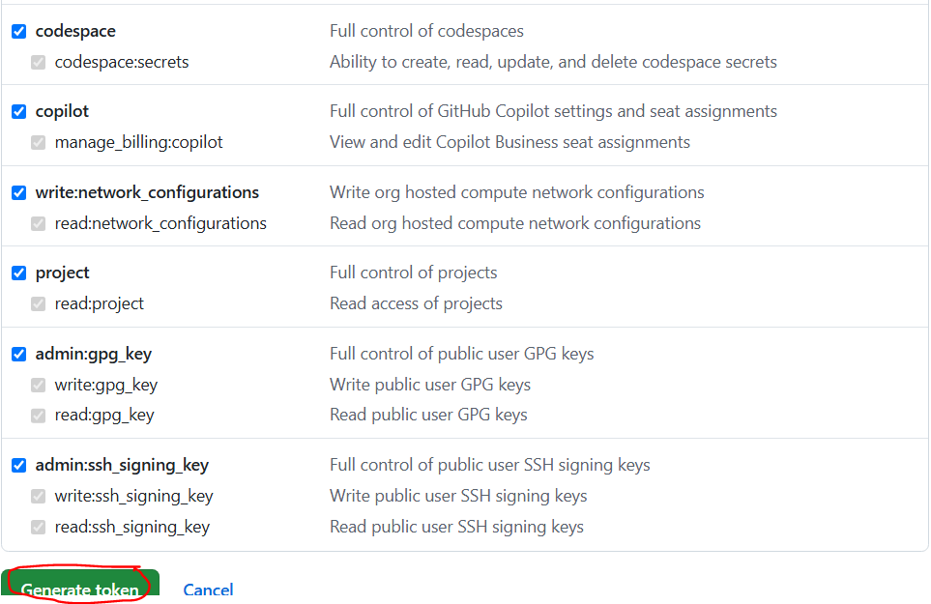
- Now give that token in the putty. The code is copied to repo. How can we check means go to your repositories🡪bank-web-application.
